Judge a book



In this project, you will investigate whether it’s really possible to judge a book by its cover.

You will make a game in Scratch to see if a computer can guess the genre of a book based only on a picture of its cover.

To do this, you’ll first need to train your computer to recognise book covers.

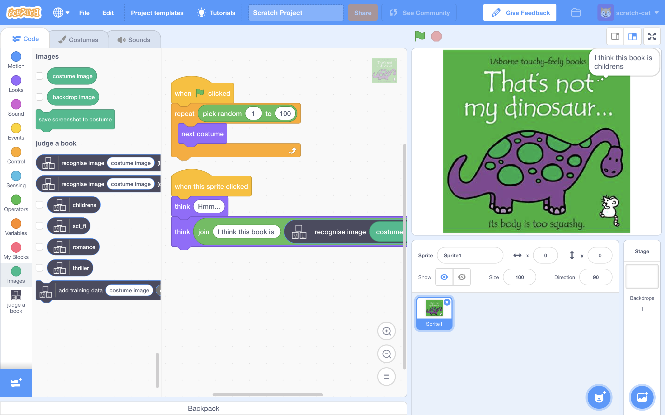

This project worksheet is licensed under a Creative Commons Attribution Non-Commercial Share-Alike License

http://creativecommons.org/licenses/by-nc-sa/4.0/

1. Go to <https://machinelearningforkids.co.uk/> in a web browser
2. Click on “**Get started**”
3. Click on “**Log In**” and type in your username and password  
   *If you don’t have a username, ask your teacher or group leader.*
4. Click on “**Projects**” on the top menu bar
5. Click the **“+ Add a new project**” button.
6. Name your project “judge a book” and set it to learn how to recognise “**images**”. Click “**Create**”  
   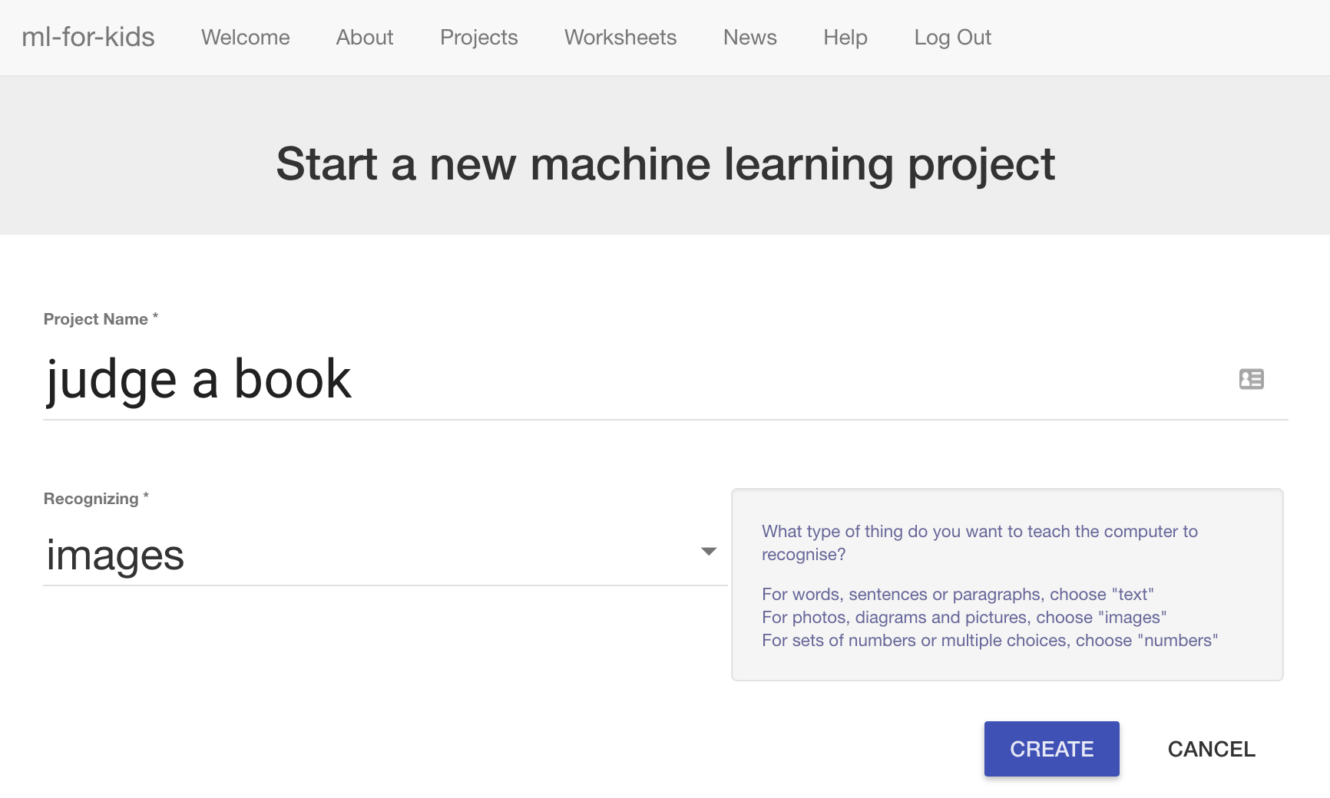
7. You should now see “**judge a book**” in your projects list. Click on it.  
   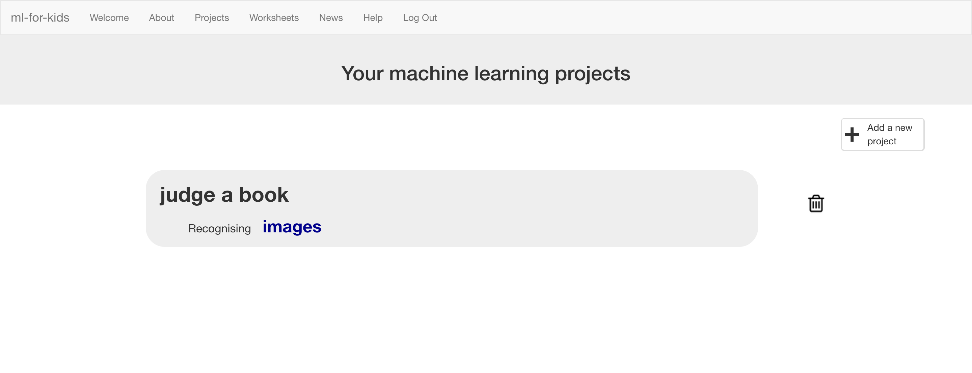
8. Click the “**Train**” button  
   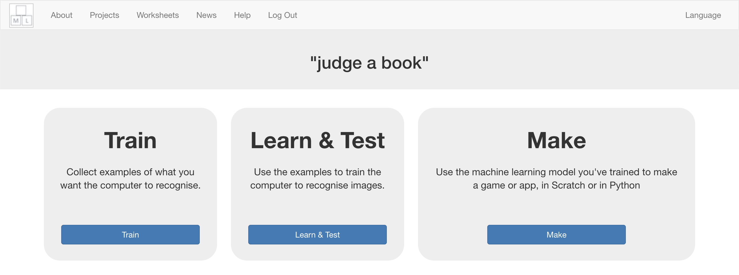
9. Choose a few genres of books.   
   *“Genre” means the type of story*.   
   *For the rest of this worksheet, I’ll be using:   
    “children’s”, “sci fi”, “romance” and “thriller”.   
   Choose your own. You don’t have to have four – two or three is fine, too.*
10. Use the “**+ Add new label**” button to create a bucket for each genre of book you’re using.  
    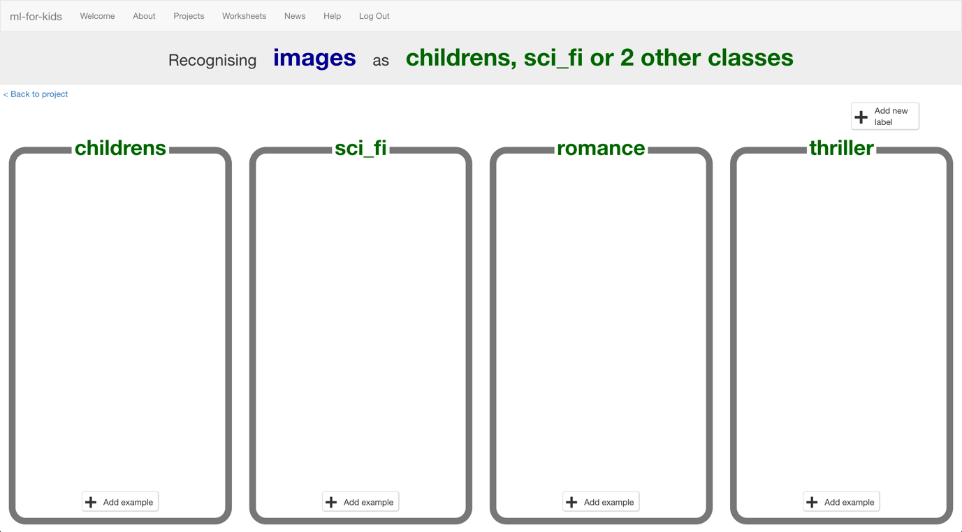
11. In another web browser window, find pictures of book covers.  
    *You need to find a website of pictures of book covers. This could be a library website, or a site that sells books like Amazon. Find a site that arranges books by genre already to make it easier for you.*  
    *Resize the windows so your training buckets are next to the book site.*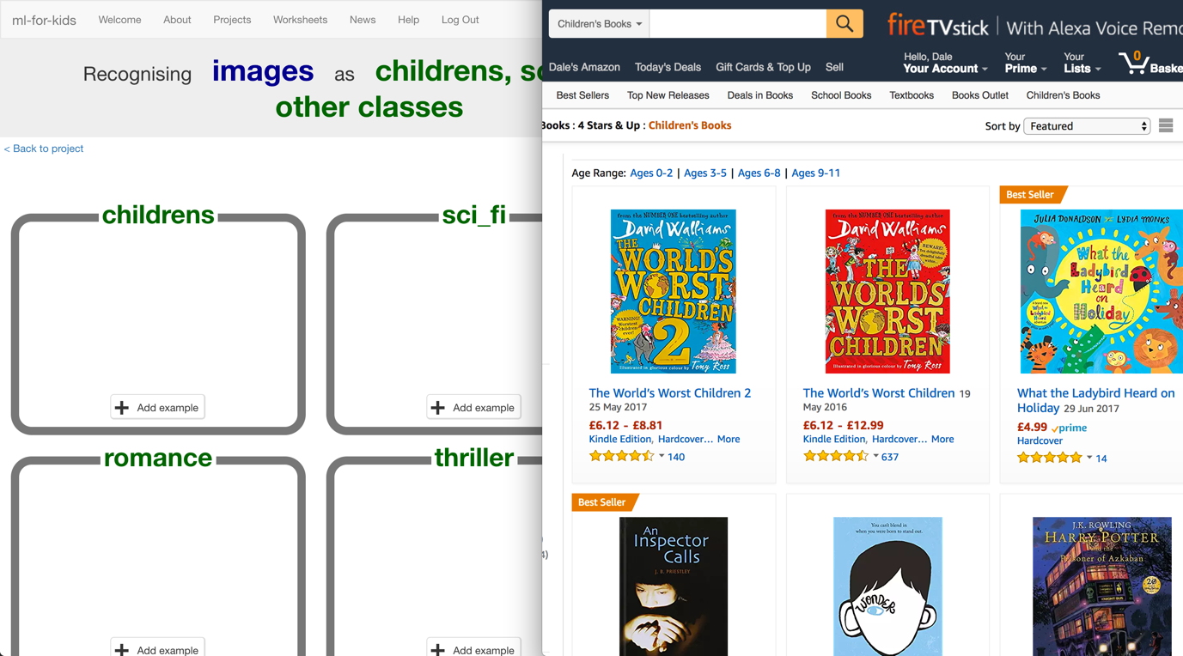
12. Find pictures of book covers in each genre you’ve chosen. Drag the best examples into the buckets in your training page.   
    *Try and find about 20 examples of each genre.*   
    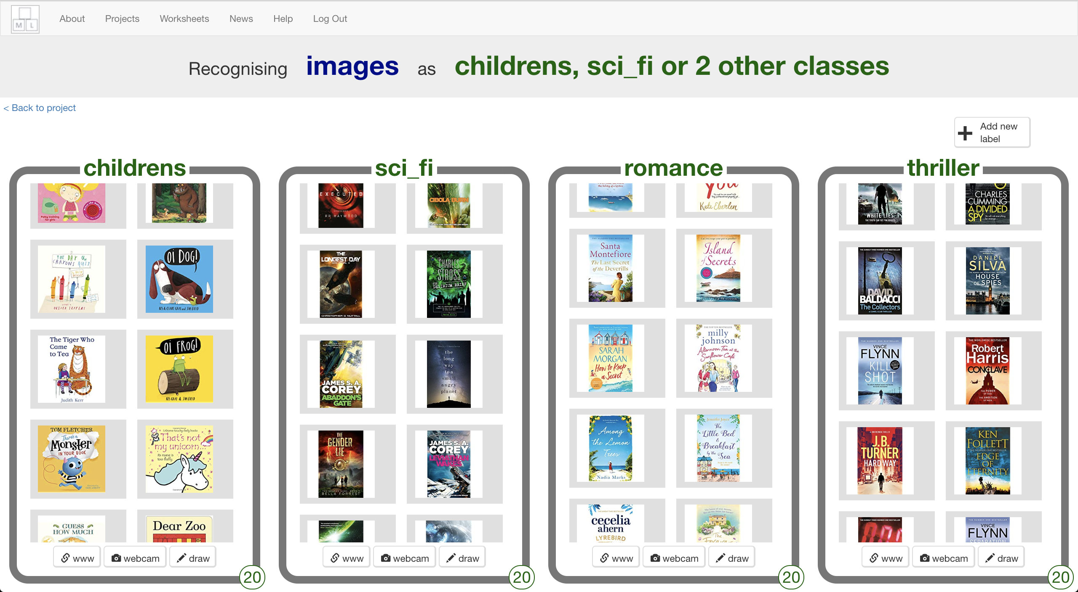
13. Save some different pictures of book covers to your computer.   
    *Ask your teacher or group leader if you’re not sure how to save a picture from a website.*   
    *These are the pictures that you’ll use to test the computer with.   
    You need some of each of your four genres. It’s important that none of these are the same as the covers you gave to the computer in step 12.*    
    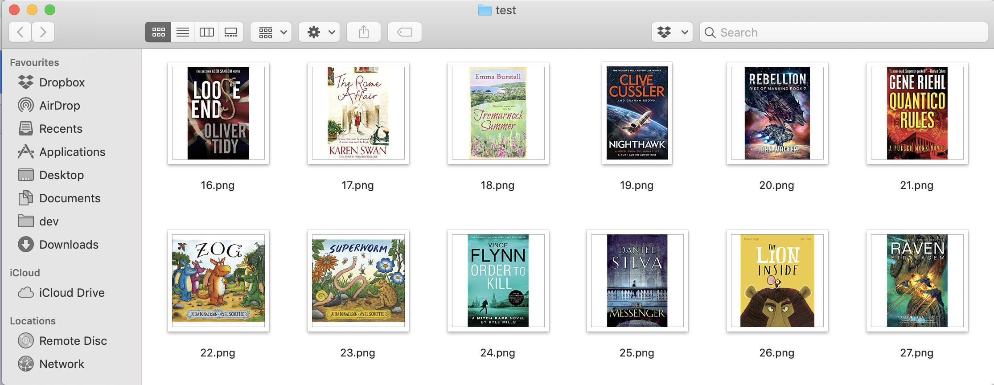
14. Click the “**< Back to project**” link. Then click “**Learn & Test**”.
15. Click “**Train new machine learning model**”.  
    *As long as you’ve collected enough examples, the computer should start to learn how to recognise covers from the examples you’ve given to it.*  
    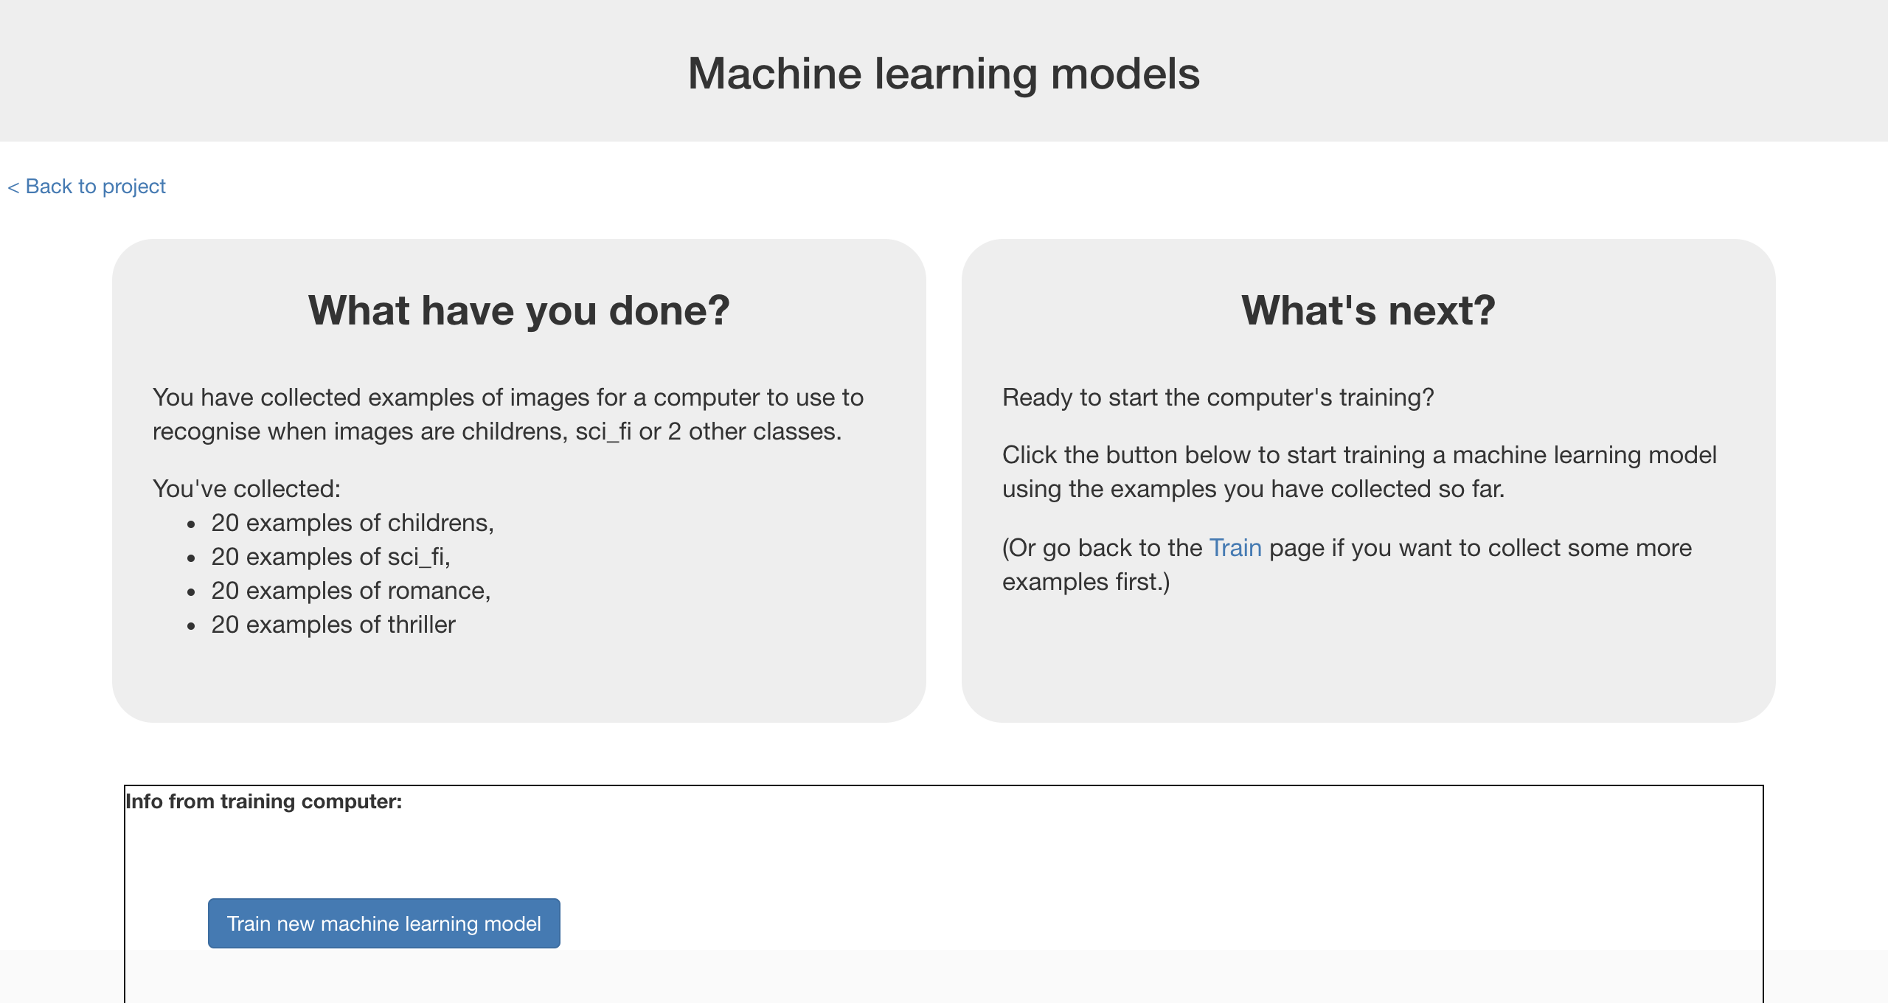
16. The training might take a few minutes to complete  
    *You can carry on and start making your Scratch project, but it won’t work until the training has finished.*
17. Click the “**< Back to project link**”
18. Click the “**Make**” button  
    
19. Click “**Scratch 3**”  
    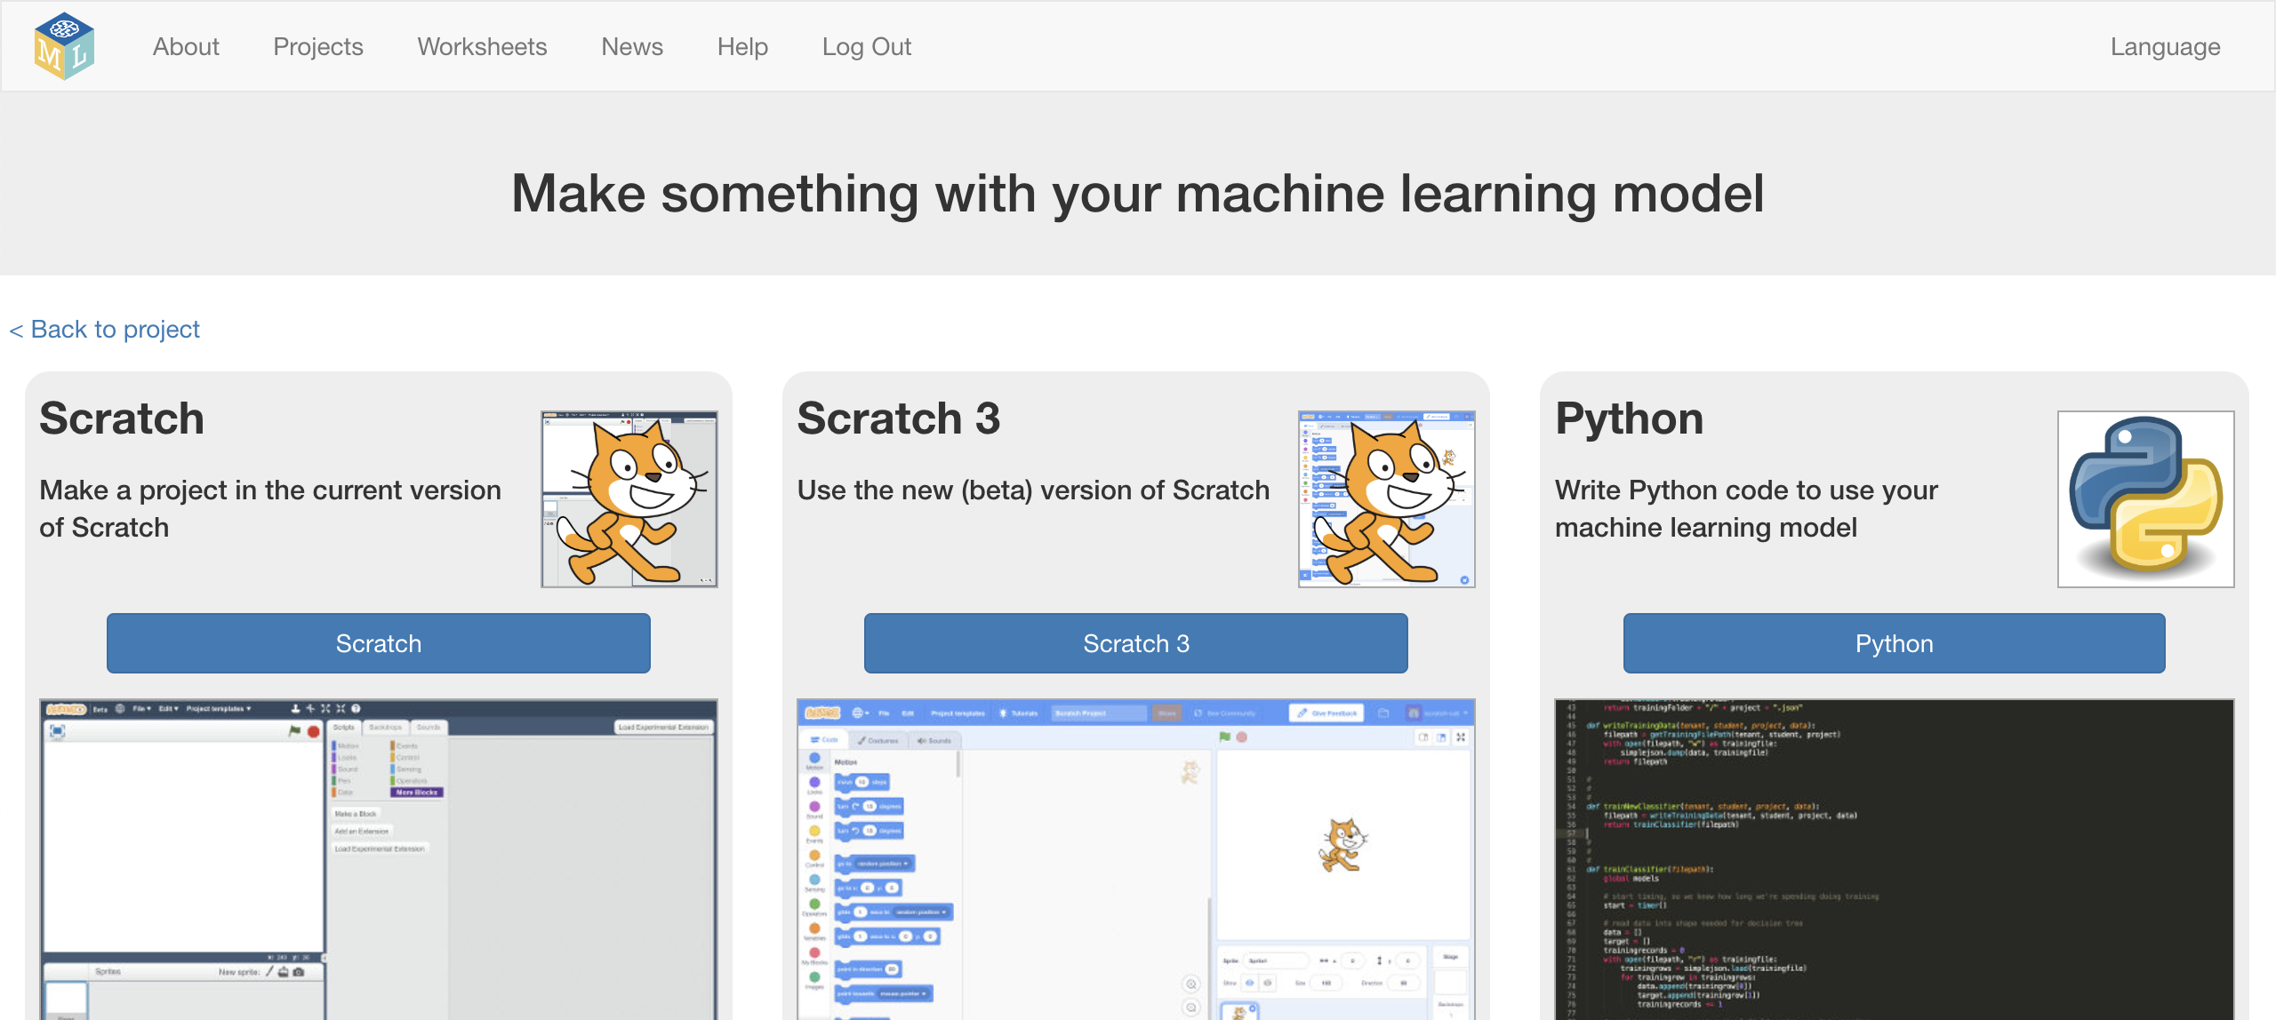
20. Click “**Open in Scratch**”  
    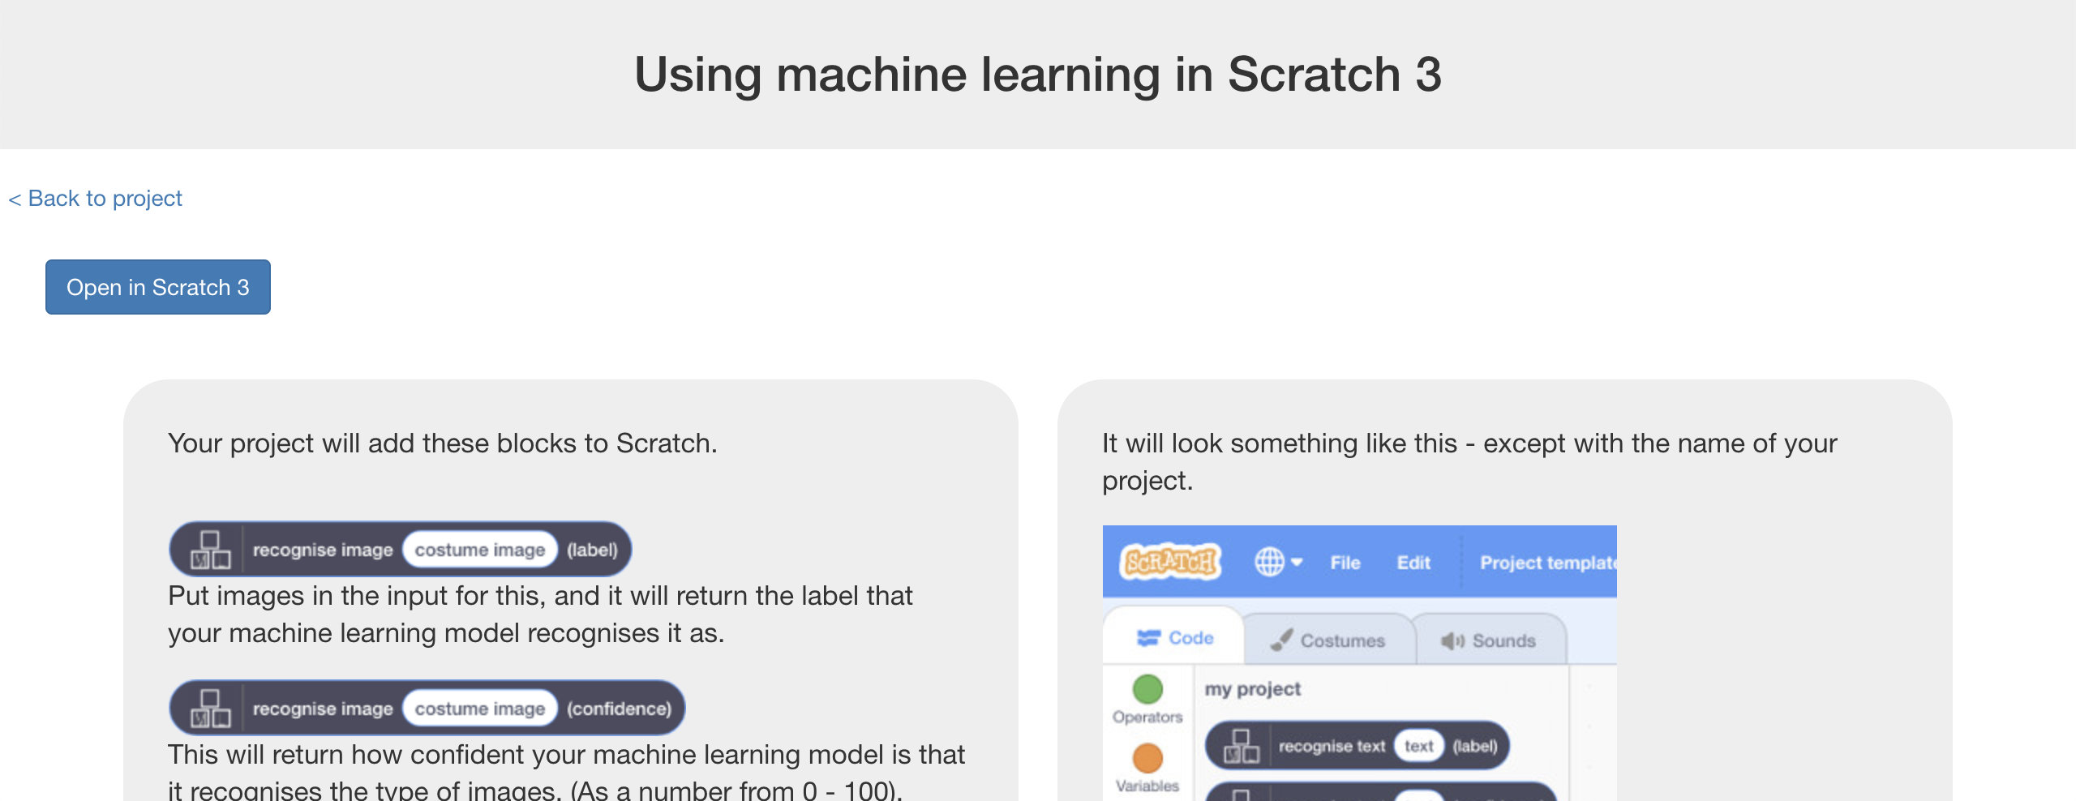
21. Scratch 3 is still quite new, so you might need to click “**Try it!**”  
    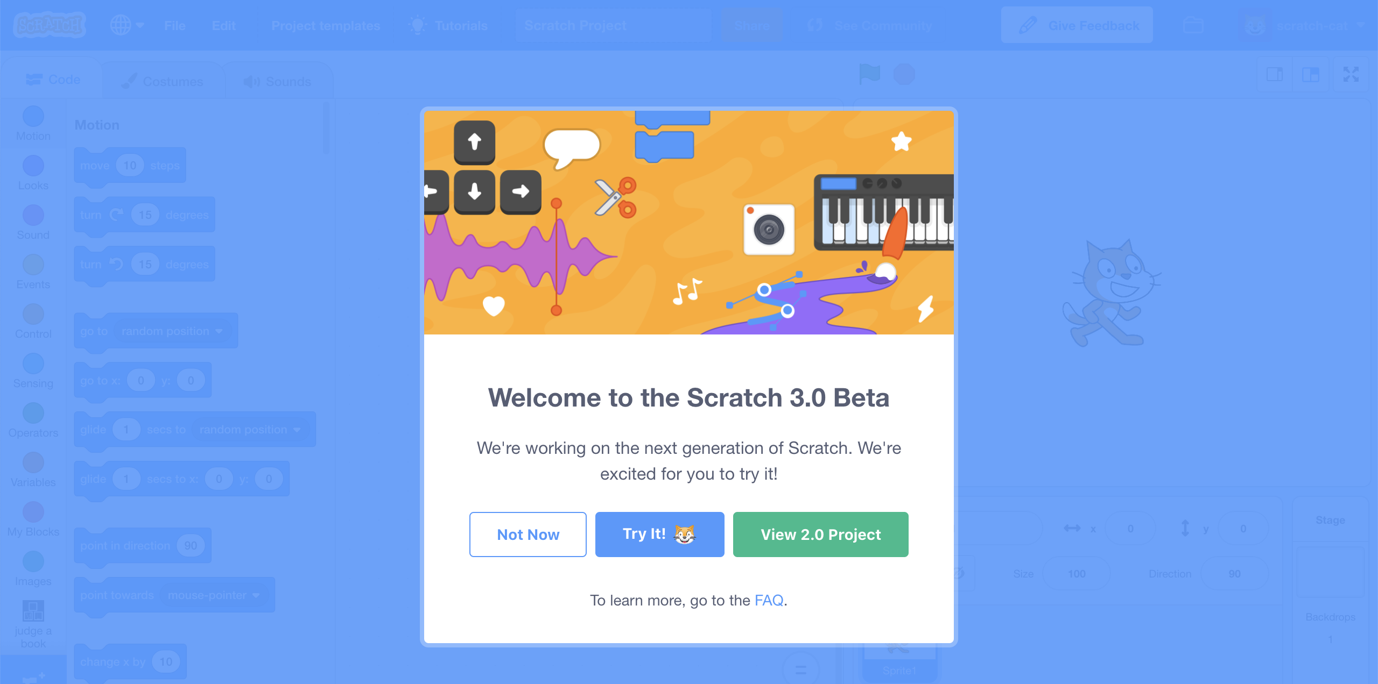
22. Click the “**Costumes**” tab  
    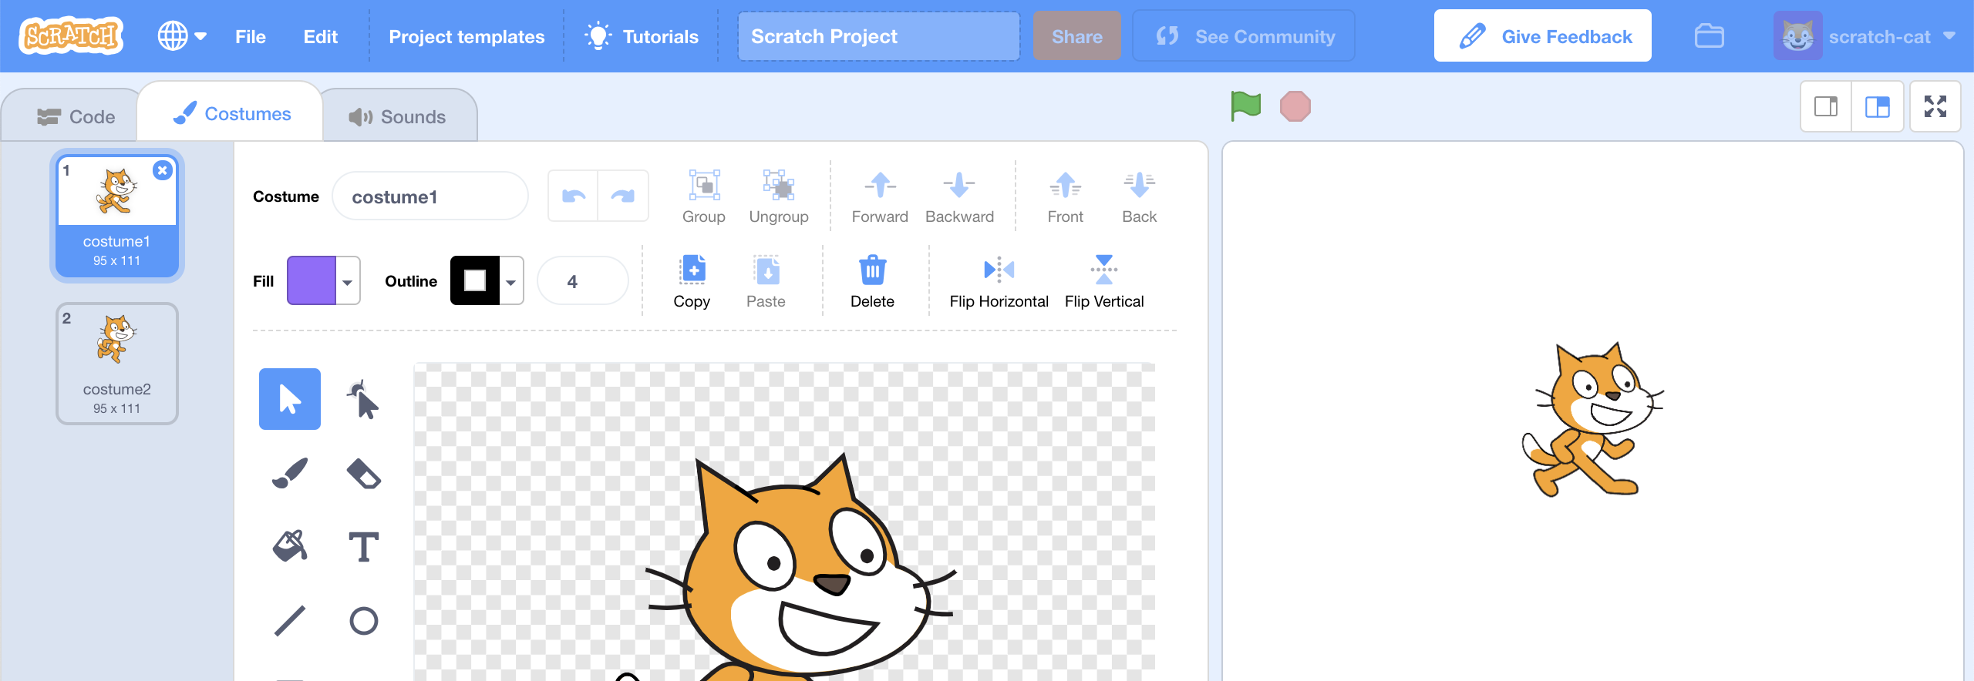
23. Click “**Upload costume**” in the bottom left  
    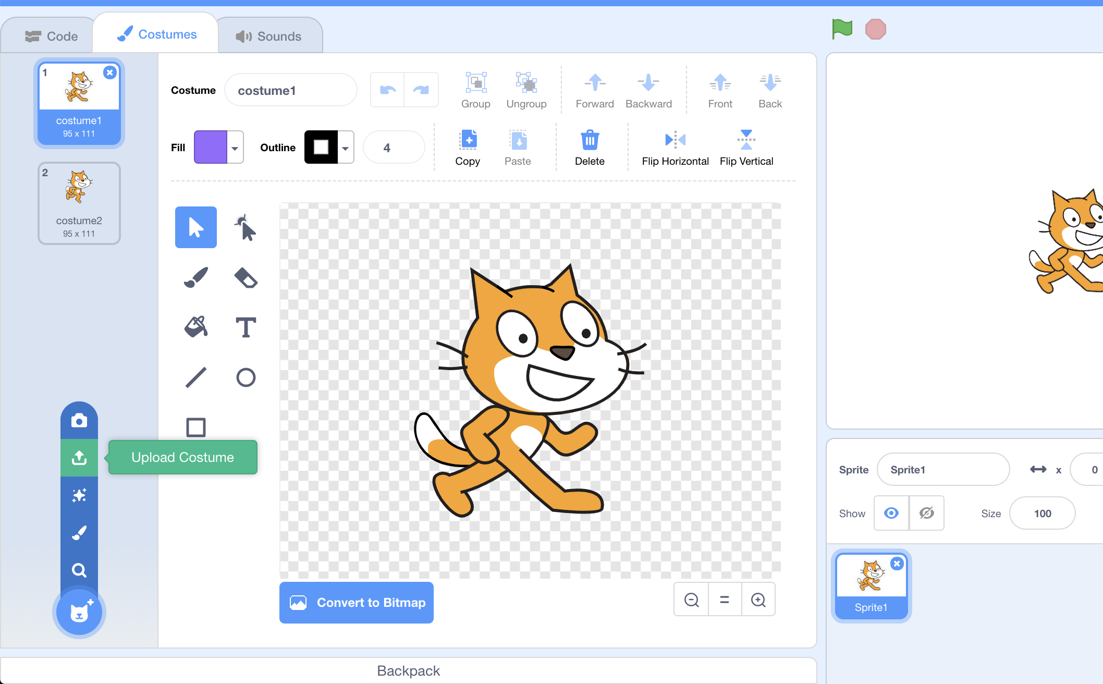
24. Find the pictures that you saved in Step 13  
    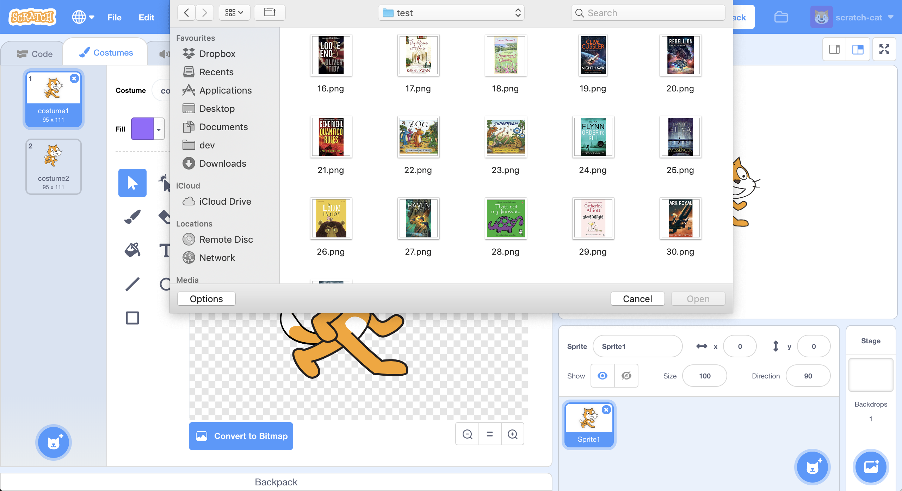
25. Add the first book cover as a costume  
    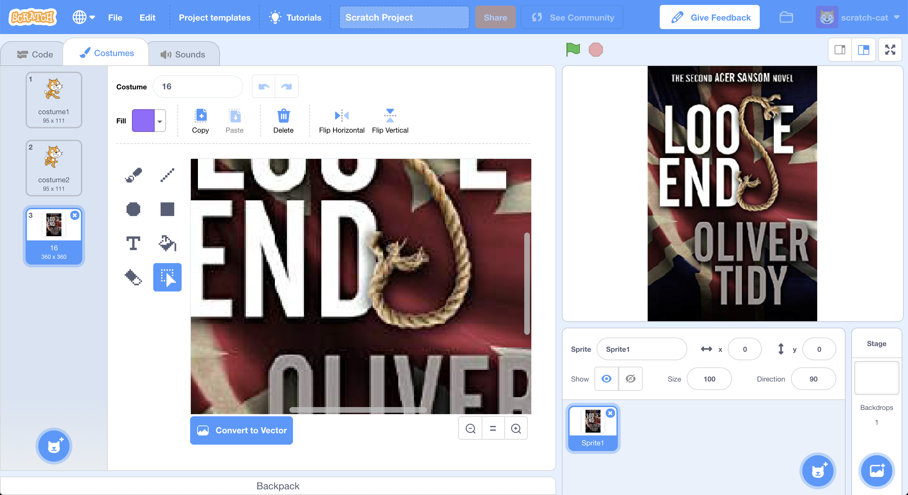
26. Do that again, to add all of the test covers from Step 13 as costumes  
    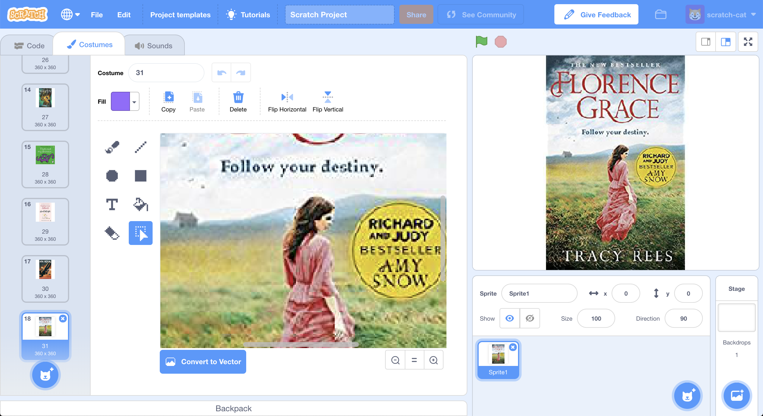
27. Delete **both** of the cat costumes  
    *Scroll to the top of the list of costumes and delete the cat costumes by clicking on them, and then clicking the blue cross*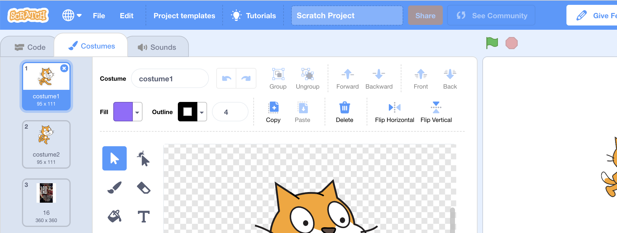
28. Go back to the “**Code**” tab  
    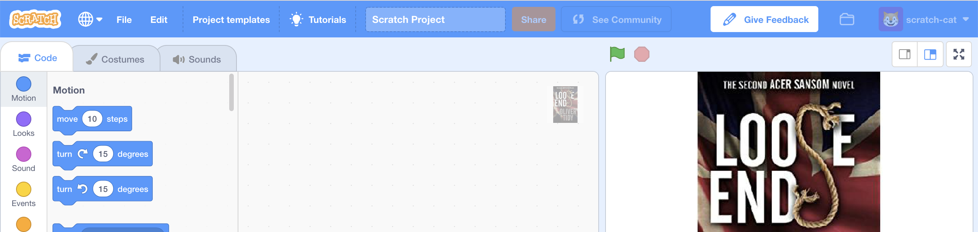
29. Enter this script  
    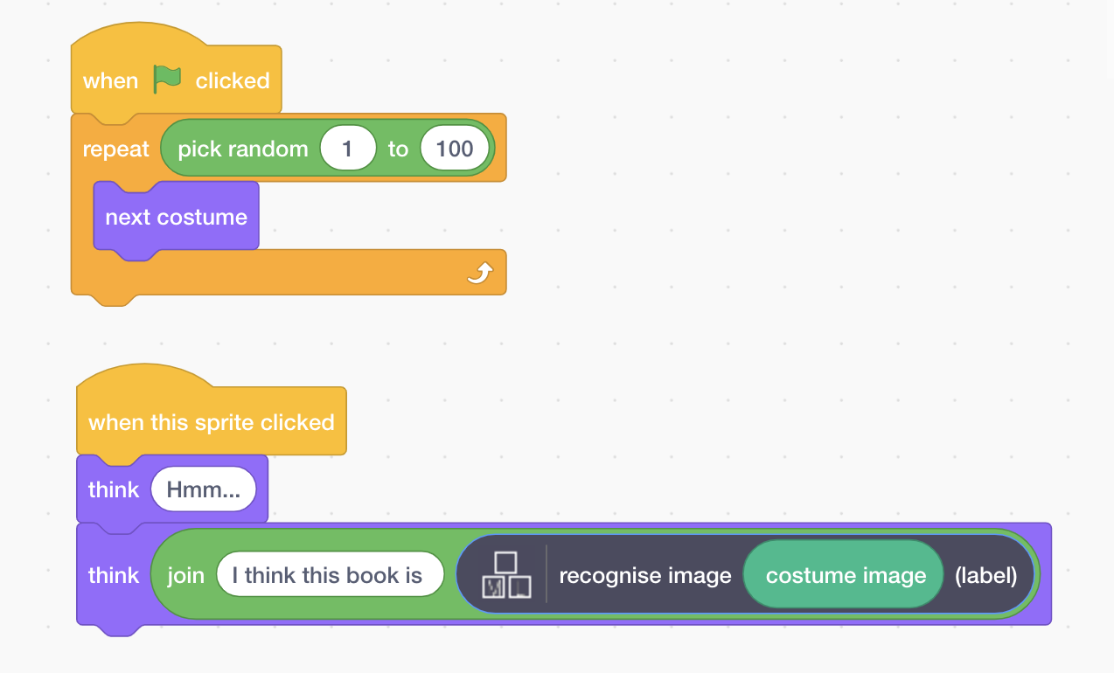
30. It’s time to test!  
    To make this fair, you haven’t shown the test images to the machine learning computer.  
    *Click the full-screen icon, and then click the green flag.  
    Your Scratch script will choose a random test cover  
    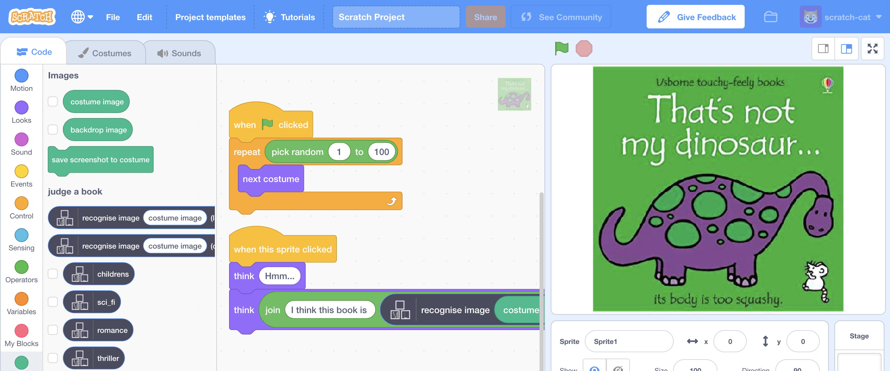  
      
    Click on the book cover  
    Your Scratch script will try to recognise the type of book  
    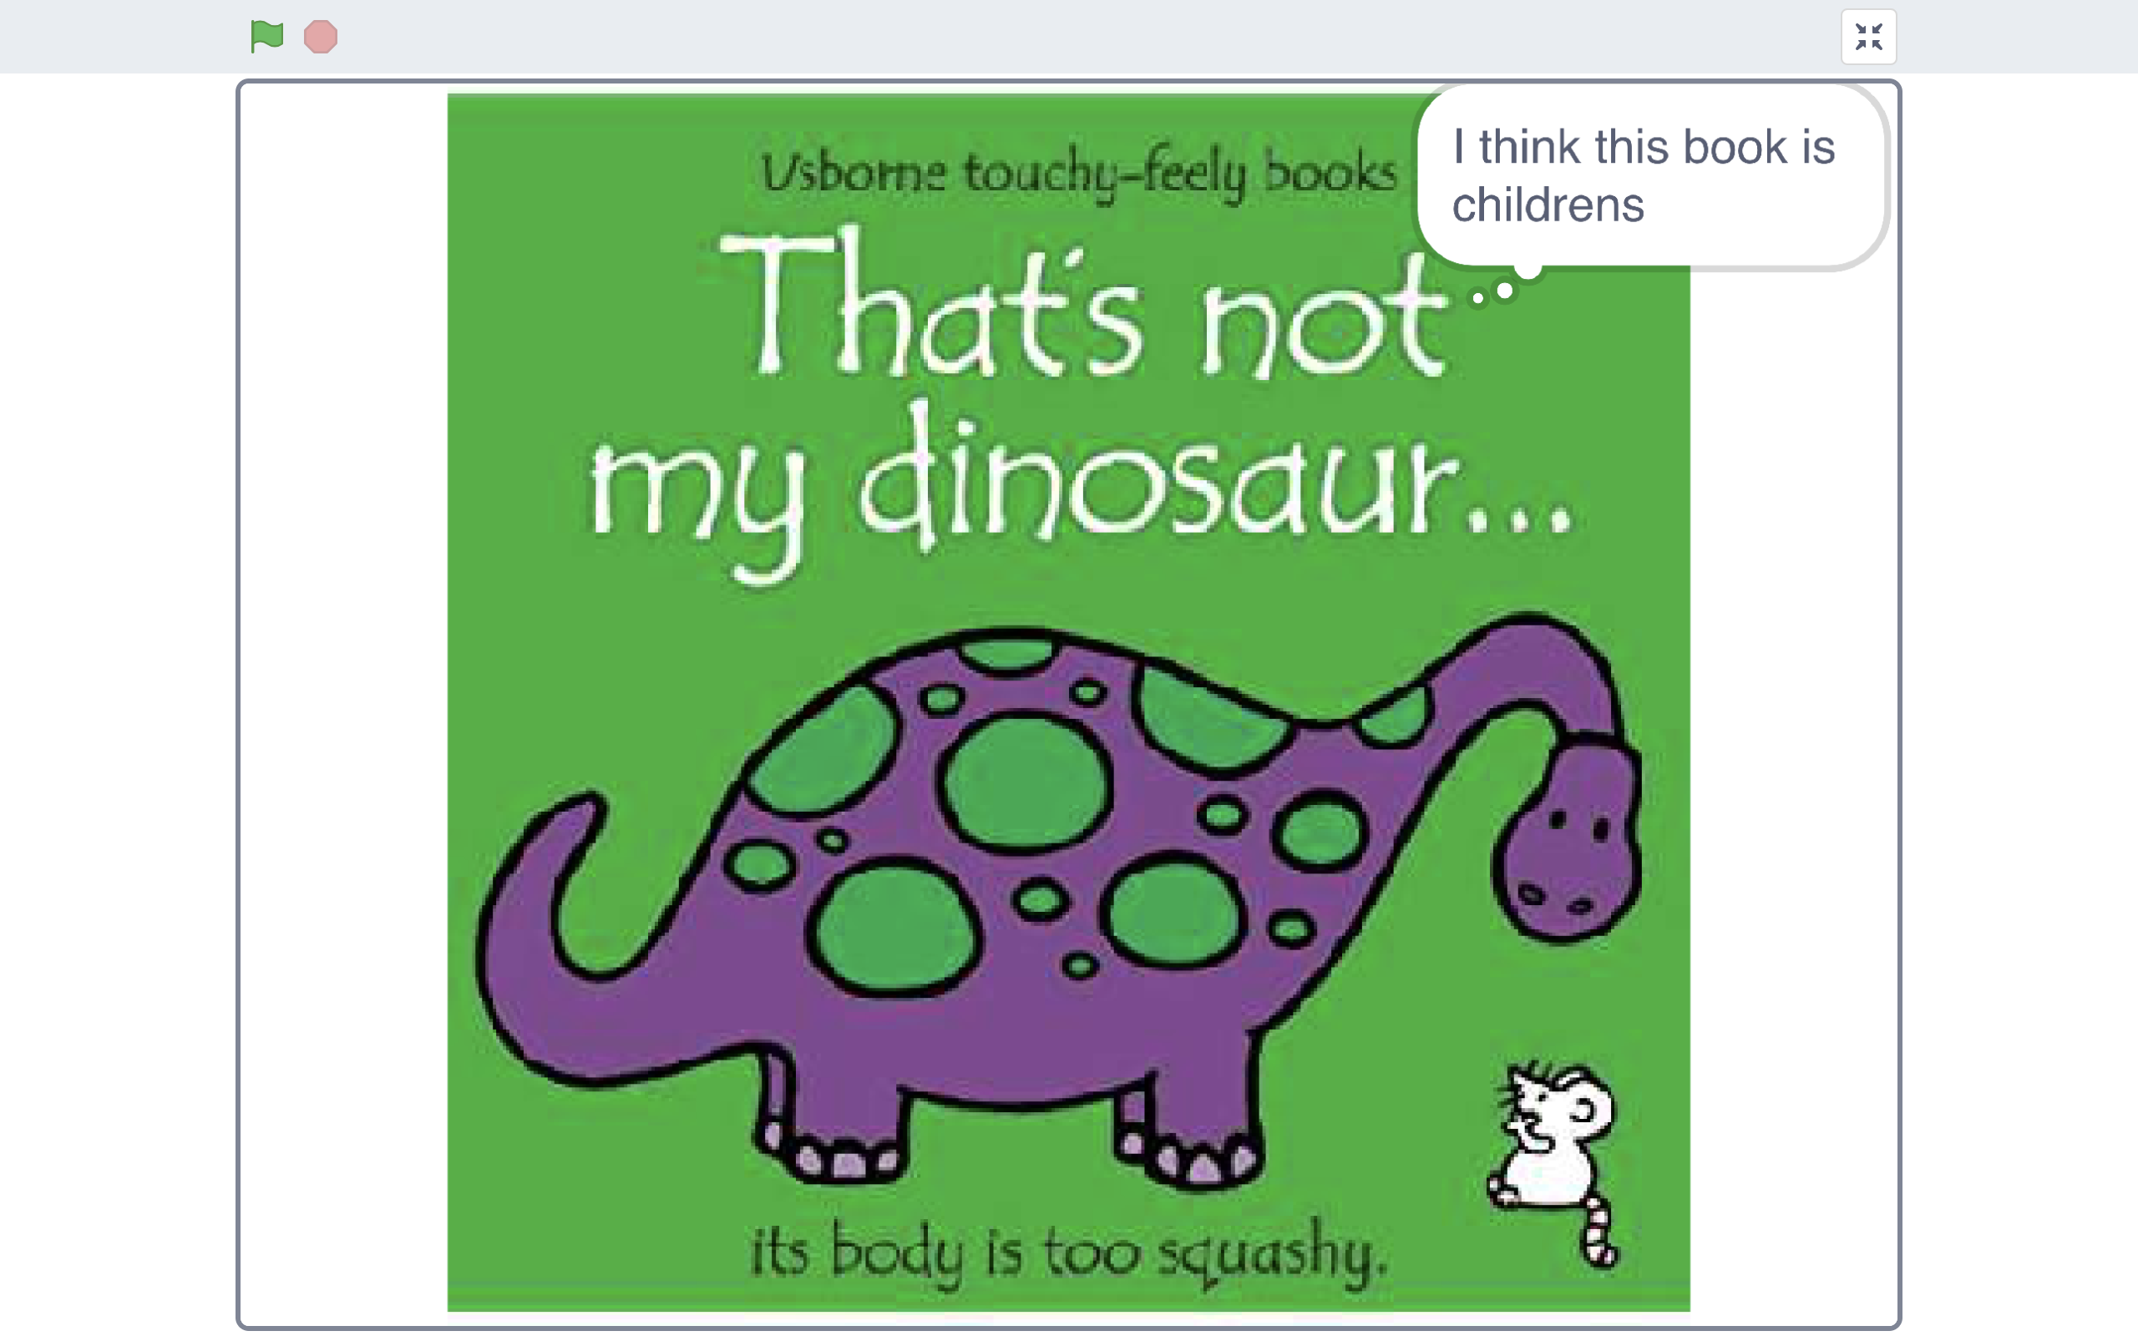*

**What have you done?**

You’ve trained a machine learning model to classify pictures. The computer learned from patterns in the colours and shapes from each of the images you’ve given it. These were used to recognise new covers.

**Ideas and Extensions**

Now that you’ve finished, why not give one of these ideas a try?

Or come up with one of your own?

**Alternative project ideas**

Instead of book covers, why not try:

* album covers – train a computer to recognise the music genre of an album from a picture of the cover – do pop music albums look different from rap albums?
* movie posters – train a computer to recognise the type of movie based on a picture of the poster – do action movie posters look different from period drama movie posters?